|  |  |  |  |  |  |
| --- | --- | --- | --- | --- | --- |
| Date | 13-Dec-22 | | | Tester Name | Richard Belanger |
| Environment | Penfax - Test | | | Login used | TEST2 |
| Operating System | Select OS | Version: | Update: | | |
| Software Used | Select Software | Version: | Update: | | |
| Select Software | Version: | Update: | | |
| Release version | 22.4.1 | | | | |
| Title | M27 Reversal and Adjustment through OLC and DCT | | | | |
| Test Type | Regression | | | | |
| Test Scenario | M27.04 Backdate a contribution | | | | |
|  |  | | | | |
| Expected Results | Pay period dates should be editable in Payroll History.  Change in pay period dates should be reflected in Contribution History.  HAS should be updated according to the pay period end date. | | | | |
| Pass/Fail | Pass | | | JIRA# | N/A |

Describe your steps with screenshots:

1. Bring up an active MEPP member and note down details from Member Profile.

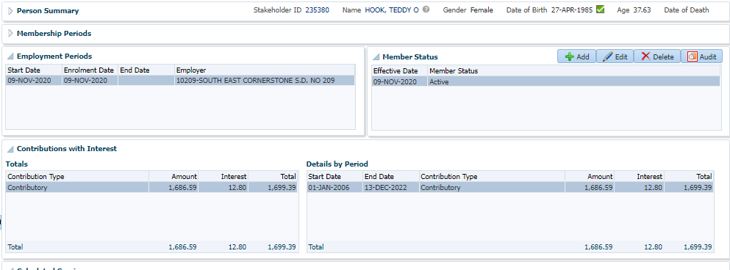

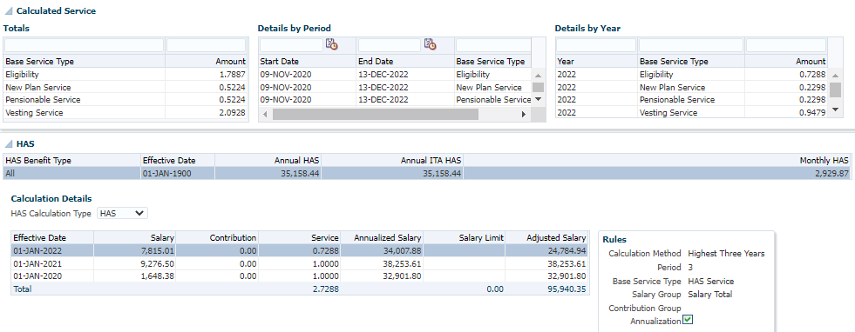

1. Go to Contribution History.

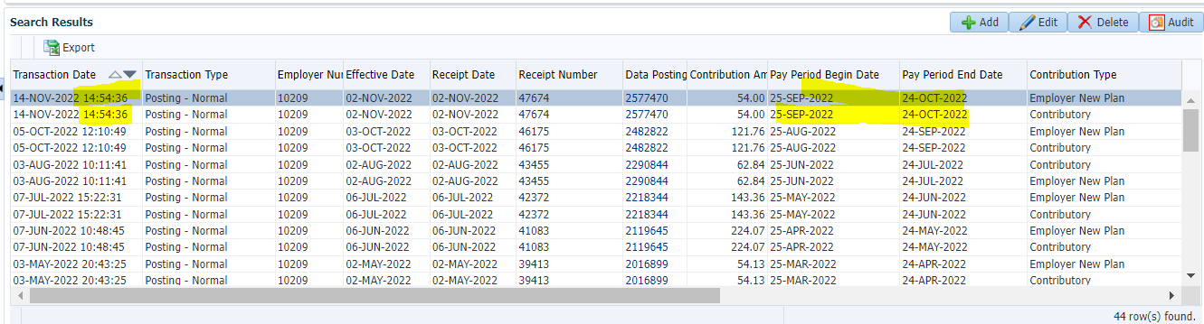

1. Go to Payroll History.

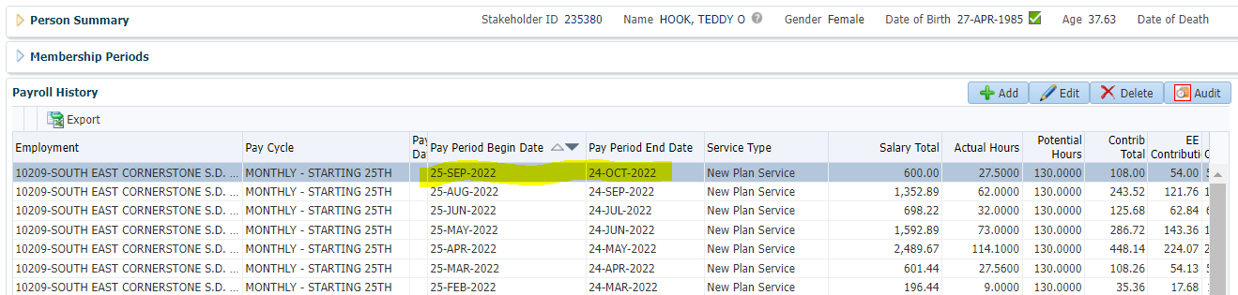

1. To backdate a contribution, highlight the record and then click on Edit.
2. Enter the pay period begin and end dates in the past, leave other details as is and click on Save.

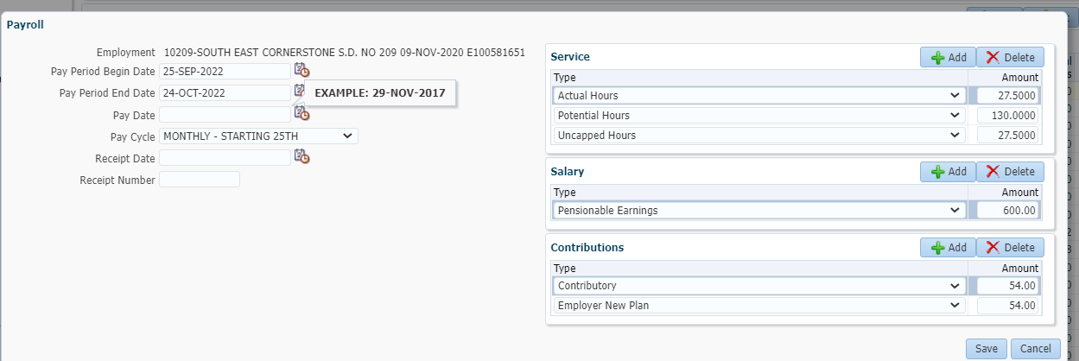

1. Go to Contribution History.

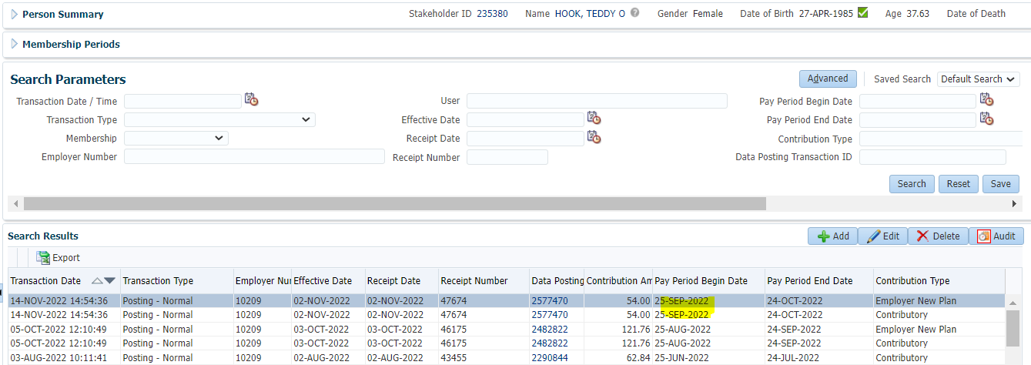

1. Go to Member Profile. HAS should be updated as per the pay period end date.

